INTRODUCTION

The Importance of Vocabulary

Vocabulary is very important in language learning; and it is hard to imagine learning a language without vocabulary. All language skills are concerned with words. In listening, learners hear words; in speaking, they speak words; in reading, they face words; and in writing, they use words. In addition, in pronunciation practice, ideally learners practice the pronunciation of sounds within word context. It is strange to practice sounds independently of words. Furthermore, if learners understand the words by which the sounds are learned, learning becomes more meaningful, more communicative, and of course more effective than otherwise. So important is vocabulary that a grammarian calls it “the flesh” of a language, being the structure the skeleton.

How to Study Vocabulary

Considering the importance of vocabulary as explained above, it is highly urgent to find effective ways of teaching and learning vocabulary. Aware or not, individual learners employ certain ways of memorizing words which they find helpful. Some dutifully look up at the dictionary for the meaning of words they encounter in the reading materials. Others memorize a certain number of words a day. Still others use special stiff cards, where on one side they copy English words, and the opposite side the Indonesian equivalence. They can take the cards wherever they want and learn through them whenever they find convenient time and place. Nowadays, thanks to technological breakthrough learners rely on electronic dictionary for vocabulary development. There must be many other techniques used by language learners, and there is nothing wrong with them as far as the learners find them helpful.

LEARNING VOCABULARY USING

ASSOCIATION STRATEGY

Association Strategy was inspired by William F. Mackay in his book Language Teaching Analysis (1961). In a small section of the book concerning grouping language items to be taught, Mackay suggests that items which are related should be grouped together and taught at the same time. This strategy is based on a very familiar phenomenon.

Phenomenon

When one hears or sees something, consciously or unconsciously he automatically associates this “something” with something else to which it is related; or that “something” reminds him of something else. We can conclude from this phenomenon that it is much more effective and efficient to group and memorize related words together than to memorize random ones.

With Association Strategy, new words are expected to

(1) Remind learners of the words they already know.
In other words, new vocabulary reinforces the mastery
of known words, or vice versa.
(2) Remind learners of words they know vaguely, and therefore encourage them to open their dictionary for the meaning to make sure
(3) Make learners aware of their ignorance of certain words, the Indonesian equivalents of which they know well. In this situation, it is likely that the learners check the dictionary for the English words. Thus, learning takes place.
For example:

Suppose a new item “bitter” (pahit) appears on a learner’s reading material. This word makes him remember the word “empedu”. Because he does not know the meaning of “empedu” and he does know that “pahit” is closely related to “empedu,” he will check the dictionary for the English of “empedu”.

In order to achieve maximum result, learners are encouraged to
employ this strategy in reading activities, rather than simply
matching words out of a list. With some adaptation, following are
some types of association as proposed by William Mackay.

PREDICATION ASSOCIATION

When hearing the words “predication” one associates it with the word “predicate”. In turn, he will associate the latter with “verbs”. Predication Association is a relationship between an object and verbs related to it.

Example: water drink → We drink water
flow → Water flows

lung breathe → People breathe with their lungs.

radio listen → I listen to the radio every morning.

Predication Association can be systematically classified into:

- What one can DO by using the object. Here when the verb is used in sentences, the word “with “ should be used.

Examples : knife - cut → We cut with a knife.

slice → We slice with a knife.

- What one DOES to or against the object.* Note that the verbs here are used transitively

Examples: knife - sharpen → Sharpen the knife! It is blunt.

- brandish → The crazy man is brandishing
a knife.

Water - splash → Children like to splash water
when they are bathed by their mother.

We apologize for the inappropriate use of “to”
and “against” here. It is deliberately used to differentiate
this type from the first one which requires “with
c. What the object itself DOES

Examples: air - blow → The air blows.

water - flow → Water flows into the cave

sun - shine → The sun shines brightly this
morning.

Exercise 1:

Think of verbs associated with the following objects. First, ask yourself “What do I do by using this object?” Second, “ What do I do to or against this object? Third, “What does this object do?” After you match the objects and the verbs, use them in sentences.

1. mechanic 6. regulation 11. air 16. money
2. typist 7. telephone 12. god 17. computer
3. war 8. flower 13. appointment 18. flag
4. mistakes 9. president 14. teeth 19. paper
5. promise 10. water 15. shoe 20. bed

Exercise 2:

For your seatmates to fill in:
Quickly jot down as many objects as you can and as they come to your mind. The least you think about your items, the more interesting it will be. Do not hesitate to include abstract nouns. After you have finished, exchange your work with your seatmates’ and do as required. When this is done, discuss your work together with your seatmates.

Exercise 3:

Associate the following verbs with the parts of your body:

1. scratch 6. beckon 11.tiptoe 16. frown
2. rattle 7. nudge 12. motion 17. pace
3. breathe 8. chew 13. type 18. pinch
4. kneel 9. point 14. bite 19. think
5. poke 10. blink 15. wave 20. crawl

Exercise 4:
Give the name of the man who:
sells meat
paints pictures
cuts hair
makes bread
sells tickets in a bus
writes for the newspapers
administers the law
carves statues
obtains coal from the ground
investigates crimes
looks after the sick
sees something happen
cures sick people
control traffic
works on a ship
Travels for pleasure
sells fruit and vegetables
cultivates land
sells metal goods
operates the sick
makes chairs and tables
sells fish
sells tobacco
carries luggage

Exercise 5:

Match the animals on the left row with their sounds o the right row. Some animals make more than one sound

dog horse crow low

cat hen buzz hiss

bee cow cackle croak

sheep purr mew twitter

pig howl bray neigh

donkey chirp grunt snarl

frog snake bleat bark

duck cock growl sparrow

ATTRIBUTIVE ASSOCIATION

When one hears the word attribute, the words mark, quality, characteristics, etc. may come to his mind. Attributive Association is a relationship between something with its typical characteristics.

Examples: ball - round → A ball is round.

ice - cold → Every where ice is cold.

fire - hot → Fire is always hot.

This type of association can be extended to non-typical adjectives that can be used to described objects.

Examples: question A question can be easy, difficult, simple, complicated, explicit, implicit, short, long, etc.
meeting A meeting can be long, short, boring, exciting, lively, formal, informal, etc.

Exercise 6:

Match the following objects with adjectives that can be used to describe them.
1. eel 6. gas 11. rubber 16. blood
2. tiger 7. water 12. glass 17. sugar
3. gold. 8. darkness 13. wire 18. gall
4. paper 9. box 14. ink 19. writing
5. atom 10. leather 15. comedian 20. manager

Exercise 7:

For your seatmates to fill in:

Jot down as many adjectives as you can and pass your list to your friends to complete with the appropriate nouns. Clue: an adjective is a word that answers the question “How”. As before, the least you give thoughts to your items, the better.

Exercise 8:

Think of more materials like water, sand, glass, etc. What words are usually used to describe them?

COORDINATION ASSOCIATION

This is a relationship between something and other things of the same kind, class, or category. (Coordination: of the same order or rank)
Examples: chair - table, cupboard, desk
post office - auditorium, mosque, church,
shopping center.

Exercise 9:

Match the following with the things of the same class, kind, or category

1. nose 4. president 7. lion 10. helicopter
2. happiness 5. round 8. bee 11. biology
3. banana 6. sweet 9. magazine 12. internist

Model sentences:

- Chair, table, cupboard, desk are all furniture
- Post office, auditorium, mosque, church are all buildings.

SUBORDINATION ASSOCIATION

Subordination Association is a relationship between something and its subdivisions (Subordinate: placed or belonging to a lower order or rank).

Examples:
furniture - table, bed, desk, cupboard, etc
insect - bee, fly, beetle, ant
shape - round, rectangular, triangle

Exercise 10:

Match the following with their subclasses or kinds

1. mammal 5. natural disaster 9. disease
2. taste 6. calculation 10. vehicle
3. emotion 7. color
4. body of water 8. clothing

Model sentences :

- Table, bed, desk, cupboard are all furniture
- Kinds of insect are bee, fly, beetle, ant, etc.

SUPRAORDINATION ASSOCIATION

This is a connection between something and the class or kind to which it belongs. (Supra : above, over)

Examples: magazine - reading matter
cabbage - vegetable
scissors - cutting implements

Exercise 11:

Match the following objects with the class they belong to:

1. multiplication 5. question mark 9. eagle
2. malaria 6. helicopter 10. piano
3. ring 7. house
4. better 8. sofa

Model sentences:

- Magazine is a reading matter
- One kind of reading matter is magazine.

WHOLE-PART ASSOCIATION

Whole-Part Association is a connection between something as a whole (unit) and its components or parts. Whole-Part Association should be differentiated from Subordination Association which concerns with ranks, divisions or classes

Examples: tree - trunk, bark, root, leaf, etc.
face - nose, mouth, eye, forehead.
car - engine, seat, steering wheel, windshield.

Exercise 12:

Write the parts of the following objects.

1. mouth 5. foot 9. door
2. bicycle 6. box 10. arm
3. house 7. knife
4. clock 8. mountain

Model sentences :

- A tree consists of the trunk, root, leaves, etc.
- Among other parts of a car are engine, steering-wheel, windshield.

Exercise 13:

Think of any objects from the previous exercises and mention their components.

PART-WHOLE ASSOCIATION

Part-Whole Association is a link between something and the thing
it is a part of. This link should be differentiated from Supraordination
Association, which deals with classes or categories.

Examples: propeller - helicopter
stem - flower
collar - shirt

Exercise 14:

Match the following parts with the objects they are part of

1. keyhole 5. tube 9. handle
2. nail 6. receiver 10. toe
3. palm 7. minute hand
4. slope 8. wheel

Model sentences :

- A propeller is the part of a helicopter (that rotates)
- Stem is the part of a flower (that we hold)

COMPLEMENTARY ASSOCIATION

This is a link between something and another thing that makes it
complete and useful (complement: something that completes
or makes perfect)

Examples:
engine - fuel
needle - thread
refrigerator - electricity
arrow - bow
shuttle cock - racket
screw - screwdriver

Model sentences :

- Without fuel an engine is useless
- For an engine to function, there should be fuel

Exercise 15:

Think of other things that are useless without the presence of other things.

MINIMAL-PAIRS ASSOCIATION

A Minimal Pair is a pair of words whose meaning are different simply because of a pair sounds (not a pair of letters) which they have. Sounds which are paired among others are long vowels versus short vowels, such as / i: / vs / i /, / Ɔ: / vs / Ɔ /, / u: / vs / u /. Among consonant sounds are voiced consonant sounds versus voiceless consonant sounds, such as / d / vs / t /, / k / vs / g /, / s / vs / z / etc.

Following are some pairs containing long / i: / versus short / i / :

leak - lick read - rid
leave - live seat - sit
bead - bid eel - ill
deem - dim peel - pill
heed - hid deed - did
reap - rip deep - dip
sheep - ship lead - lid
sleep - slip least - list
peak - pick seek - sick
reach - rich lead - lid
heal, heel - hill
scene, seen - sin
week, weak - wick
steal, steel - still
eel - ill

Exercise 16

Complete sentence with the minimal pair of a word in the same sentence. Do not refer to the list unless you have tried hard.

Examples: Peel the banana and insert a…….. in it.
Answer: pill

After the boy stepped on an eel, he fell ………
Answer : ill

1. Later when they sleep, I will ……the paper into the pocket of
one of them.

2. Mind you don’t bite your lip when you……..

3. The can is leaking and a dog is………..the mess.

4. There are some ………aboard the ship.

5. The hikers’……….hurt after they climbed two hills.

6. Get rid of this cheap book. It is disgusting to………….

7. The rich man will not………..popularity if he continues to be
ignorant.

8. Before the climbers reach the…………..they will pick some
unique pieces of rock..

9. Is this………occupied? May I sit here?

10. My wife replaces the ……….of our stove every eight weeks.

Following are exercises on more words containing other paired vowel sounds. For each item one or two sentences are provided. Fill the blanks with the minimal pair of words in the same sentence or in the complete sentence.

Exercise 17:

Words containing sound / S / versus short / ʃ/.

1. The short employee was busy to ……. out the letters.

2. That man sipping juice with a straw works in …… company.

3. My daughter was screaming as if she had been struck by shock
when she found a big spider in her ……….

4. With one eye closed, can you shoot that bird ?
Does this jacket ….. you ?

5. Don’t sit on that bench. There is ….. on it.

6. Sue was wearing a worn out ….. to school.

7. Are you going to sell this precious ….. ?

8. I saw a prisoner in his cell polishing a ….. .

9. For the sake of friendship, the two men will ….. hands warmly.

10. A shack is a rough cabin. It is common to have a ……
containing various objects there.

11. There was a ….. between rival groups outside when our
class (American pronunciation, hence Am pron.) was going on.

12 She bought a …….. for herself.

13. A cut in a shin must be very painful. To steal is a ….. .

14. On his way back from the bank to save money, my father
decided to stop at the barber’s to ….. .

15. The delegates’ faces were shining when ….. .
the long awaited contract.

Exercise 18:

Words containing long / Ɔ: / versus short / Ɔ / .

Examples : After the magician raised his rod the tiger ………
to respond.
Answer : roared

The port was still far away. They took a rest and drank water they brought in a big ……
Answer : pot

1. The policemen took a short break and aimed his…… precisely at
the target.

2. In court, a baby in a ….. does not look very strange.
3. ‘Sought’ is the past form of seek. ‘………’ is a drunkard

4. ‘Naught’ means ‘nothing’, ……… something

5. ‘……’ means stem, ‘Stock’ means supply
6. In the sport auditorium, the athletes have to stand in the assigned . ..... when listening to briefings
7. The fisherman was looking for a strong cord to catch the …..

Exercise 19:

Words containing sound / æ / versus / /.

1. The cat has a severe …. on its back..
2. It is wasteful to buy a leather bag for a single ….

3. Can you suck air out of this strong ….. ?

4. At last (Am. pron), facing a new problem the man lost his … to abuse the lone girl.

5. The employee drags the bag containing ……
6. We must shorten the ….. so that the boat doesn’t capsize easily.
7. I am sure that the old man left his …. in the hut.

8. If people lack courage, they tend to rely on …..

9. It might be for fun if people …. a shivering person.

10. Just pay me a ….. for massaging your back..

11. The lighted cigarette butt attracted a …..

12. For the ….. to come out, pass (Am. pron.) your fingers below
the wound and press it lightly
13. The athlete was mad finding his shoe stuck in the …..
14. Switch on another lamp so you can see the …. on my neck.
15. As an acrobat, you should be able to walk with a cup on your …

Exercise 20:

Words containing sound / ә: / versus / a : /.

1. We heard that the sightless person had a…… time in following
the lecture.

2. Who will burn the poor farmer’s …..?

3. The news that a star has just exploded did not …. the people.
4. Celebrities may travel far just to get the best …. coat.
5. A foreigner was barred entry to our country because he was
carrying a protected bird.

6. Before aiming, carefully the archer wiped …… off his dart.

7. After the workers finished enjoying a nice ….. , they played card.

8. Your mother’s heart will break if you …. her feeling.

Exercise 21:

Words containing sound / s / versus / z /.

1. A bus does not ….. A bee does.

2. The patient will immediately ….. off because of this heavy dose.

3. You see, that native speaker cannot pronounce …… correctly.

4. Grace is beauty. To ….. is to feed on grass.

5. During the race he could momentarily ….. his hands.

6. Sue plans to go to the ….. with her students.

7. I don’t know why my kid’s eyes widen when he sees a piece
of……

8. The singer’s voice turned …… for unknown cause.

9. He will lose his pet if he ties it that …….

Exercise 22:

Word with sound / t / versus / d /.

1. Come to my side! We will enjoy the …. from here.

2. A toy cod might be found in a ……

3. Even the best jockeys find it had to write when they …. on
horseback.

4. In court, the prosecutor produced a piece of …. for the
defendant to identify.

5. This is a private property, no one has a right to ….. along this
stretch of path.

6. We guess there are about …. lions in the den.

7. There are people who are fond of typing with a big ….

8. A ….. does not always mean ‘yes’ for all people.

9. That piece of ….. on your seat is not showing.

10. With a single tin one may make …..

HOMONYM ASSOCIATION

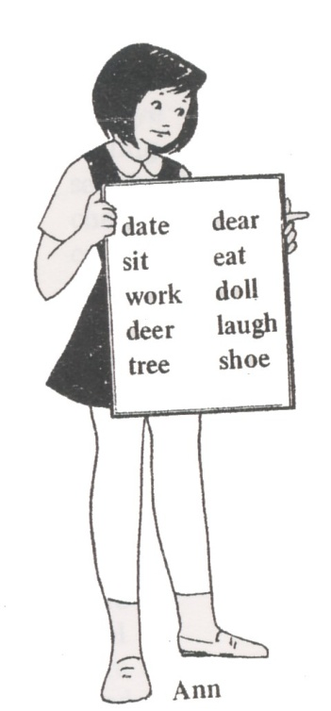

There is a list of words on Ann's chart.
Can you pick out two words which sound alike?
The words are 'deer' and 'dear'.
Has 'deer' the same meaning as 'dear'?
No, both words are different in meaning.
Such words are called Homonyms.

A Homonym is a word that is the same in sound as another but different in meaning.

Here is a list of homonyms. Study them carefully.

air heir ball bawl
allowed aloud beach beech
ate eight bean been
bear bare none nun
beat beet oar ore
blew blue one won
boar bore pail pale
board bored pain pane
bough bow pair pear
brake break pause paws
buy by / bye piece peace
ceiling sealing peal peel
cent sent/scent pitcher picture
cheap cheap plain plane
coarse course pore pour
dear deer praise preys
die dye pray prey
fair fare rain rein
find fined raise rays
flour flower read red
fool full right write
four fore ring wring
fur fir road rode
groan grown root route
hair hare rose rows
heal heel sale sail
hear here scene seen
heard herd sea see
higher hire sew sow
him hymn sight site
hole whole sole soul
hour our son sun
key quay soot suit
knew new stair stare
knight night tail tale
knot not their there
knows nose threw through
lain lane throne thrown
lead led tide tied
loan lone to two/too
made maid waist waste
mail male wait weight
main mane weak week
meat meet wood would
missed mist

Exercise 23:

Choose the correct word. Then write out each sentence.

e.g. We (one, won) the race yesterday.
We won the race yesterday.

1. Open the windows and let in some fresh (heir, air).

2. The fisherman repaired his (oar, ore).

3. (None, Nun) of the boys turned up in the evening.

4. A lion has a (main, mane).

5. This is (their, there) house.

6. Did you (brake, break) the vase?

7. He (knows, nose) your uncle.

8. The (maid, made) went to the market.

9. The motorist was (fined, find) ten dollars.

10. He bought a (whole, hole) bag of flour.

Exercise 24:

Fill in the blanks with the correct words in the brackets.
Then write out the sentences.

e.g. This ……… was sung by ………. (hymn, him)
This hymn was sung by him.

1. We ……… our dinner at ……… o'clock. (eight, ate)

2. We finished ……… work in an ……… (our, hour)

3. His ……… went out to play in the ………. (sun, son)

4. The boy ………. up the………. balloon. (blue, blew)

5. He could ………. untie the ………. in the string.
(not, knot)

6. I haven't ………. the ………. book yet. (red, read)

7. Most of us ………. with our ………. hands. (write, right)

8. The ………. boys walked ………. school. (to, two)

Exercise 25:

Complete the following sentences with the homonym of a word in the same sentence.

- My neighbor was accused of trying to steal ……… from a construction site.

- The old man wanted to know whether the …… would be better the following day.
- I pray that my only donkey does not fall ………to a wild animal.

- Let me warn you not to put on those ….. -out shoes.

- When coming down the stairs, she usually…..at her late husband’s picture hanging on the wall in front of her.

- During the war the journalist……….a disguise.

- There was an order to get rid of the foul …… from the premise.

- The mailman………… the letters through the window.

- The company decided to ……. a detective even for higher pay to help them win their case.

- In the ritual, the last phase was to smear the …….. with dirt.

- With this type of cord this is not a proper………..

- In spite of the flu, my grandfather …….to Jakarta to attend his grandson’s marriage party.

- I have never heard him singing from the………

- I heard some animals were missing from the ……….

- It is great that people………. with machines.

- You do not have a…………… to write any notice on this board.

- My wife is getting bored of washing her clothes on that piece of …………

- A week before she died, the controversial artist …………. her hair blue.

- Week after week the patient became very ……….because of improper care.

- I am sure you……. the sore in your child’s back.

- Being sure that the strange ………. could not be detected, the criminal sent the package to his would be victim.

- The vet let me pour the liquid on to the infected………. of the anesthetized lion.

- It is scaring to hear the……..of the grown-up lion.

- The caller wore a shirt with a stiff……….

- There is no way to………that poisonous snake unless it is put in a strong sack and by using a proper scale.

SYNONYM ASSOCIATION

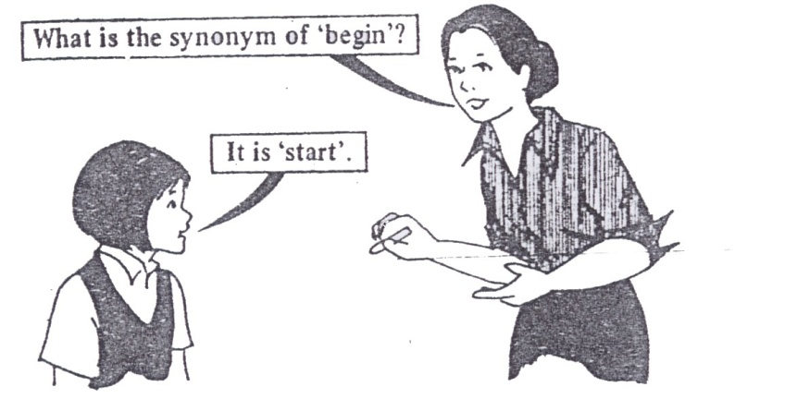

Do you know what a synonym is?
Look at the two words 'begin' and 'start'.
What similarity can you see between them?
Both words have the same meaning.
The word 'start' means 'begin'.
It is the synonym of 'begin'.

Below are some synonyms for you to learn.

aid help bright shining
also too catch capture
animal beast centre middle
answer reply change alter
ask question close shut/near
bad wicked clothes dress
beat hit collect gather
begin start conversation talk
big large correct right
blank empty cruel unkind
bottom foot cunning sly
brief short daring brave
dear expensive old ancient
disease sickness port harbour
dull gloomy powerful strong
dumb. mute pretty beautiful
edge margin protect guard
end finish purchase buy
enemy foe quantity amount
fall drop quick fast
false untrue quiet peaceful
far distant rich wealthy
gain profit rude impolite
gay cheerful sad unhappy
glad happy seldom rarely
hard difficult small little
high tall smell scent
idle lazy stop halt
ill sick talk speak
join unite thief burglar
jump leap thin lean
king emperor top summit
learn study trust believe
listen bear try attempt
look see under below
mistake error vacant empty
new modem war battle
noted well-known weak feeble
odd peculiar wide broad

Exercise 26:

Choose the word which has the same meaning as the word in bold. Then write out the sentence.

e.g. He seldom comes here. (never, rarely)
He rarely comes here.

1. The country was ruled by a powerful king. (cruel, strong)
2. The soldiers fought bravely in the war. (battle, city)
3. There is a boat under the bridge. (below, beside)
4. The headmaster gave a short talk. (little, brief)
5. The old beggar is very weak. (feeble, tired)
6. That boy is always lazy. (impolite, idle)
7. It's a rather dull day. (gloomy, cloudy)
8. My brother is lean and tall. (high, thin)
9. We must study hard for the examination. (learn, remember)
10. The scouts camped at the foot of the hill. (below, bottom)

ANTONYM ASSOCIATION

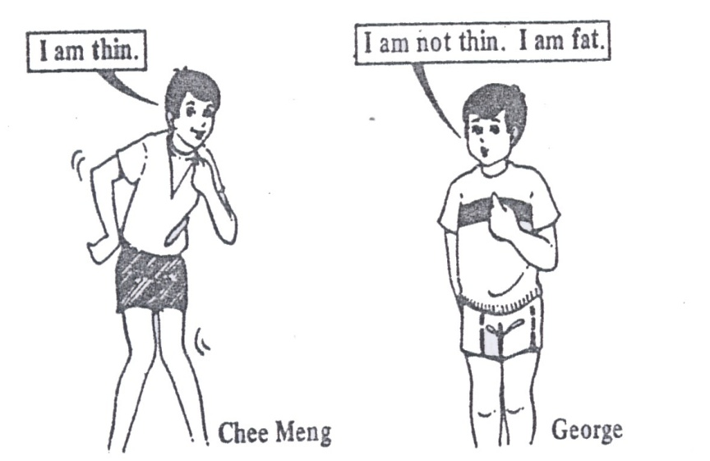

Look at Chee Meng and George.
How do they describe themselves?
Chee Meng says he is thin. George says he is fat.
He is not thin like Chee Meng.
'Fat' is the opposite of 'thin'.
It is called the antonym of 'thin'.

Study these antonyms.

above below backwards forwards
absent present bad good
add subtract beautiful ugly
alive dead before after
all none begin end
always never bent straight
ask answer big small
asleep awake black white
back front blunt sharp
bold timid found lost
bright dull fresh stale
broad narrow future past
busy idle generous selfish
buy sell give take
catch throw happy sad
cheap dear hard soft
dean dirty head tail
clever stupid heavy light
cloudy clear here there
coarse fine hide show
cold hot high low
come go hill valley
cool warm in out
cry laugh inside outside
coward hero interesting dull
daily nightly joy sorrow
dark bright kind cruel
day night lazy hard-working
deep shallow lead follow
depth height lend borrow
die live life death
difficult easy long short
divide multiply loss win
dry wet loud soft
dwarf giant love hate
early late masculine feminine
east west master servant
empty full modern ancient
enemy friend morning evening
everybody nobody noisy quiet
everywhere nowhere north south
failure success often seldom
fair dark old new
far near open shut/close
fat thin peace war
few many plural singular
find lose polite rude
finish start poor rich
first last powerful weak
foolish wise proud humble
forget remember question answer
quick slow tame wild
right left teach learn
read write teacher pupil
rise fall these, those
rough smooth thick thin
safe dangerous this that
same different tight loose
separate join tiny huge
something nothing top bottom
spend save true false
stand sit up down
straight crooked well ill
strong weak wide narrow
summer winter win lose
sweet sour work rest
talk listen wrong right
tall short young old

Some antonyms are formed by adding a few letters before the words.

Un

certain uncertain lock unlock
dress undress necessary unnecessary
equal unequal ripe unripe
fair unfair safe unsafe
fold unfold screw unscrew
happy unhappy tidy untidy
healthy unhealthy tie untie
kind unkind true untrue
like unlike

Dis

agree disagree like dislike
appear disappear obey disobey
honest dishonest

In

attentive inattentive correct incorrect

Im

patient impatient possible impossible
polite impolite

Mis

spell misspell use misuse
understand misunderstand

The antonyms of many words ending with - full are formed by changing -ful to -less.

careful careless hopeful hopeless
harmful harmless useful useless
helpful helpless painful painless

Exercise 27:

Rewrite these sentences using the antonyms of the words in bold.

e.g. This road is rough.
This road is smooth.

1. Are the sums easy? .
2. She was absent on Monday.
3. This path is narrow.
4. Mary went to school late.
5. I have something to give you.
6. He always comes here.
7. You are a rude boy.
8. Jane is a proud girl.
9. He will lead us to the lake.
10. The man spoke in a soft voice.

Exercise 28:

Rewrite these sentences using the antonyms of the words in bold.

e.g. The fat boy is short.
The thin boy is tall.

1. He found his bag here.
2. The thick book is quite heavy.
3. The small box is on the top shelf.
4. She plays daily
5. Please open the window when you go in.
6. They want to sell the old car.
7. This knife is sharp.
8. We love that kind lady.
9. It is dangerous to swim in deep water.
10. He is clever as well as careful.

DERIVATIONAL ASSOCIATION

This is a relationship between words which originate or are derived from the same root or base form with the use of various inflections (derived: originated from or drawn from)

All English words have a root. This is the form which carries the basic meaning of the word. It can be changed by adding a form (inflection) at the beginning (prefix) or a form at the end (suffix). The root form may be any one of the four parts of speech (a verb, a noun, an adjective, or an adverb)

Exercise 29:

Noun (thing) endings

The following noun (thing) endings are very common in English. It is important for you to study them and become familiar with them.

NOUN (THING) ENDINGS

- ism sosialism  - nce excellence  -ness sadness  - ion information | - ment government  - ty beauty  - age marriage  - ship friendship

Exercise 30:

Using one of the ending above, change each of the following word into a noun (thing):

1. member ___________ 9. alcohol ___________
2. kind ___________ 10. permanent ___________
3. real ___________ 11. mile ___________
4. move ___________ 12. confuse ___________
5. human ___________ 13. leader ___________
6. elect ___________ 14. sudden ___________
7. break ___________ 15. improve ___________
8. intelligent ___________ 16. equal ___________

Exercise 31:

After you have completed the blanks, use the base forms and those with the endings in sentences.

e.g. I am a member of this club.

Membership of this club is limited to the company
employees, only.

Noun (person) endings

The following noun (person) endings are very common in English. It is important for you to study them and become familiar with them.

NOUN (PERSON) ENDINGS

-er employer  -or actor | - ist tourist  - cian musician
Exercise 32:

Using one of the ending above, change each of the following word into a noun (person):

1. teach ___________ 9. perfection ___________
2. type ___________ 10. program ___________
3. beauty ___________ 11. electricity ___________
4. ideal ___________ 12. invest ___________
5. invent ___________ 13. build ___________
6. clinic ___________ 14. natural ___________
7. special ___________ 15. advice ___________
8. ranch ___________ 16. mathematics ___________

Exercise 33:

See instruction of exercise no. 31.

Adjective endings

The following adjective endings are very common in English. It is important for you to study them and become familiar with them.

ADJECTIVE ENDINGS

- ent excellent  - ant important  - full careful  - ic economic  - less careless | - ive expensive  - ous dangerous  - al natural  - able capable  - ible possible

Exercise 34:

Using one of the ending above, change each of the following word into an adjective:

1. heart ___________ 9. courage ___________
2. nature ___________ 10. use ___________
3. athlete ___________ 11. enthusiasm ___________
4. mystery ___________ 12. motion ___________
5. help ___________ 13. tradition ___________
6. impress ___________ 14. change ___________
7. intelligence ___________ 15. permanence ___________
8. comfort ___________ 16. attract ___________

Exercice 35:

See instruction of exercise no 31.

Verb endings

The following verb endings are very common in English. It is important for you to study them and become familiar with them.

VERB ENDINGS

-en soften  -ate populate | - ize memorize  - ify notify

Exercise 36:

Using one of the ending above, change each of the following word into a verb:

1. dark ___________ 9. different ___________
2. final ___________ 10. identify ___________
3. just ___________ 11. like ___________
4. separation ___________ 12. glamour ___________
5. short ___________ 13. person ___________
6. intense ___________ 14. sweet ___________
7. investigation ___________ 15. liberal ___________
8. industrial ___________ 16. demonstration ___________

Exercise 37:

See instruction of exercise no. 31.

Adverb endings

The following adverb ending is very common in English. It is important for you to study them and become familiar with them.

ADVERB ENDINGS

- ly rarely

Exercise 38:

Using one of the ending above, change each of the following word into an adverb:

1. final ___________ 9. great ___________
2. careful ___________ 10. complete ___________
3. obvious ___________ 11. eager ___________
4. recent ___________ 12. absolute ___________
5. strong ___________ 13. correct ___________
6. perfect ___________ 14. sudden ___________
7. fearful ___________ 15. doubtful ___________
8. quick ___________ 16. regular ___________

Exercise 39:

See instruction of exercise no 31.

All Endings Together

Exercise 40:

Identify each of the following words as a noun-thing (NT),
a noun-person (NP), an adjective (ADJ), an adverb (ADV),
or a verb (V).

___ 1. heighten ___ 11. desertification ___ 21. speechless
___ 2. forgetful ___ 12. submissive ___ 22. tremendously
___ 3. imperialism ___ 13. nocturnal ___ 23. liability
___ 4. effusively ___ 14. establishment ___ 24. counselor
___ 5. cashier ___ 15. impertinent ___ 25. civic
___ 6. columnist ___ 16. impertinently ___ 26. sensitize
___ 7. aggravate ___ 17. togetherness ___ 27. ambiance
___ 8. glamorous ___ 18. pharmacist ___ 28. justification
___ 9. vintage ___ 19. craftsmanship ___ 29. interpretive
___ 10. statistician ___ 20. manageable ___ 30. personify,
Exercise 41:

All Endings Together

Circle the letter of the word that correctly completes each sentence.

1. The __________ of the news could not be stressed enough.
(A) important (B) importance (C) importantly

2. The detective __________ that the maid committed the robbery.
(A) theorized (B) theoretician (C) theoretic

3. It is __________ that they live so close to the school.
(A) convenience (B) convenient (C) conveniently

4. The patient responded __________ to the medication.
(A) weaken (B) weakness (C) Weakly

5. The psychologist explained his ideas on__________
interaction.
(A) social (B) society (C) socialize
6. Not everyone wants a job as a __________ .
(A) mortal (B) mortally (C) mortician

7. You should not __________ the problem.
(A) minimal (B) minimize (C) minimally

8. Because of a traffic __________ he had to appear in court.
(A) violate (B) violator (C) violation

9. The children ran __________ toward the entrance of the park.
(A) excitedly (B) excited (C) excitement

10. The company was unable to __________ enough profit to stay
in business.
(A) generator (B) generate (C) generation

11. She pick up a piece of __________ rock.
(A) Vulcano (B) vulcanize C) volcanic

12. He responded _________to the rude question.
(A) explosively (B) explosion (C) explosive

13. Because your medical problem is serious, you need to see a
(A) specialize (B) special (C) specialist

14. The coach was able to __________ the athletes to perform
better.
(A) motivate (B) motivator (C) motivation

15. He was not concerned about the __________ of his actions.
(A) careless (B) carelessness (C) carelessly

16. This portion of the report should be completed __________ of
the other part.
(A) independence (B) independent (C) independently

17. The view of the mountains was ___________ .
(A) magnify (B) magnificent (C) magnification

18. It was necessary for the speaker to __________ her message.
(A) clarify (B) clarity (C) clarification

19. The ___________ of the village was the soldiers' primary goal.
(A) liberate (B) liberation (C) liberal

20. He gave an __________ incorrect answer to the question.
(A) obvious (B) obviously (C) obviate

Exercise 42:

All Endings Together

The following sentences contain a number of underlined words. Each of the underlined words may or may not be correct. Circle the underlined words that are incorrect, and make them correct.

1. The police inspect organized an intensively search for the
robber.

2. The newspaper reporter did not exact appreciate the negation
comments about her article.

3. He became penniless and homeless when a seriousness ill made
him unable to work.

4. On the old college campus, the ivy-covered walls of the colonial
buildings create an aura of gentility and tradition.

5. Maya Angelou is a poem, composition, and author of two
autobiographically works, I Know Why the Caged Bird Sings
and My Name.

6. The process of Americanization encouragement immigrants to
assimilation American attitudes, cultural, and citizenship.

7. During the previous war, the national defense establish found
itself in greatness need of linguists.

8. The escalate of hostilities between the two nations has proven
far more seriousness than analyze had previously expected.

9. Social is becoming increasingly dependence on complex
computers for the arrange of its affairs.

10. If someone has an educator in the humanities. he or she is
prepared to deal with abstractions or complex and to feel
comfortably with subtleties of thought.

11. It is possible to demonstrate that the mathematical odds for success of the program increase dramatically with the additional of increased financial backing.

12. It would be fatally for the administration to underestimate the determine of the protesters to have the new law overturned.

OTHER TECHNIQUES OF
LEARNING VOCABULARY

Tip: Keep a vocabulary notebook. Write the words you learn from this book in it. Use a good dictionary. Ask your teacher to recommend one. You will need it for some exercises in this book.

Here are some ways of writing down words you want to learn.

A. Write down words that go together (collocations)

You do the exercises in this book. Sometimes, you may make
mistakes in your English. In your vocabulary book, write down:
do an exercise and make a mistake.

When words are used together like this, we call it a collocation.
You go by train, but on foot (= walking)
preposition + noun

Some people are good at languages [NOT good -in]
adjective + preposition

I saw a very tall man [NOT high man]
adjective + noun

Tip: Always write down collocations when you learn a new
word.

B. Learn words in families

Word family | Some words in the family
Temperature  Travel | hot, warm, cool, cold  ticket, passport, suitcase

Tip: Make a page for every different word family in your
vocabulary notebook.

C. Picture and diagrams

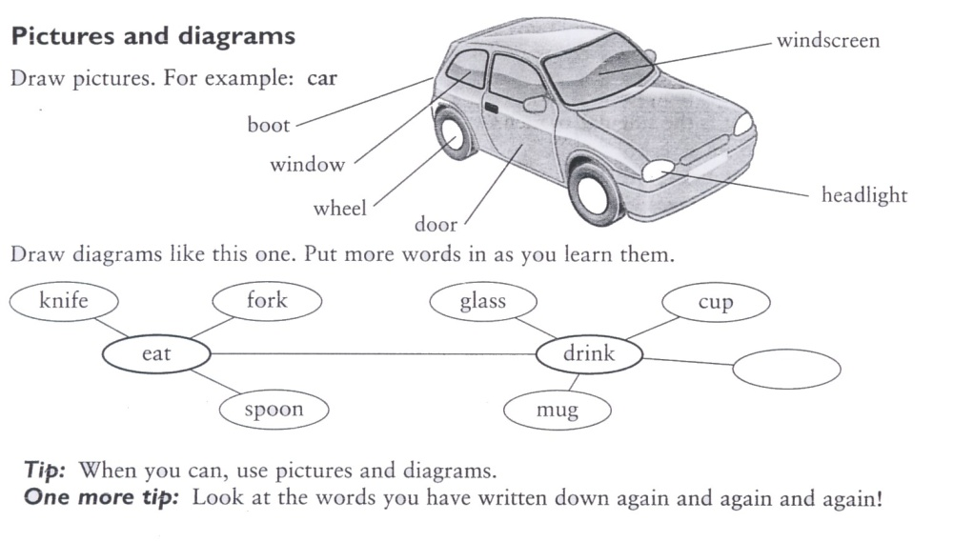

Exercises 43: Which words can go with weather? Use a dictionary.

wet high big dry warm happy cool rainy dark

wet
_____________
_____________
_____________
_____________
_____________
Exercise 44:

There are two word families here. What are they? Put them in the table. Use a dictionary.

school rain sun teacher cloud exam snow ice student

name of family | Words in family

Exercise 45:

Put words in the empty circles.

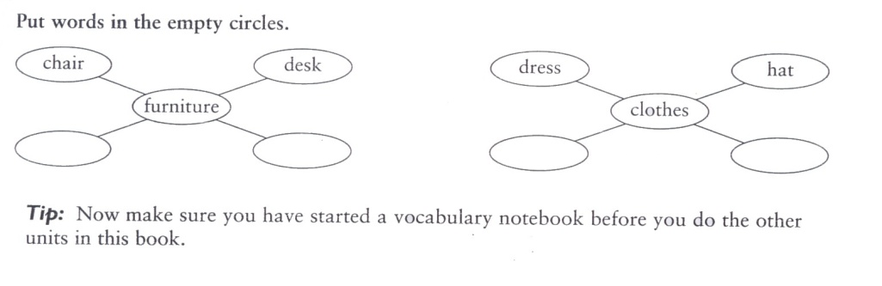

TALKING ABOUT LANGUAGE

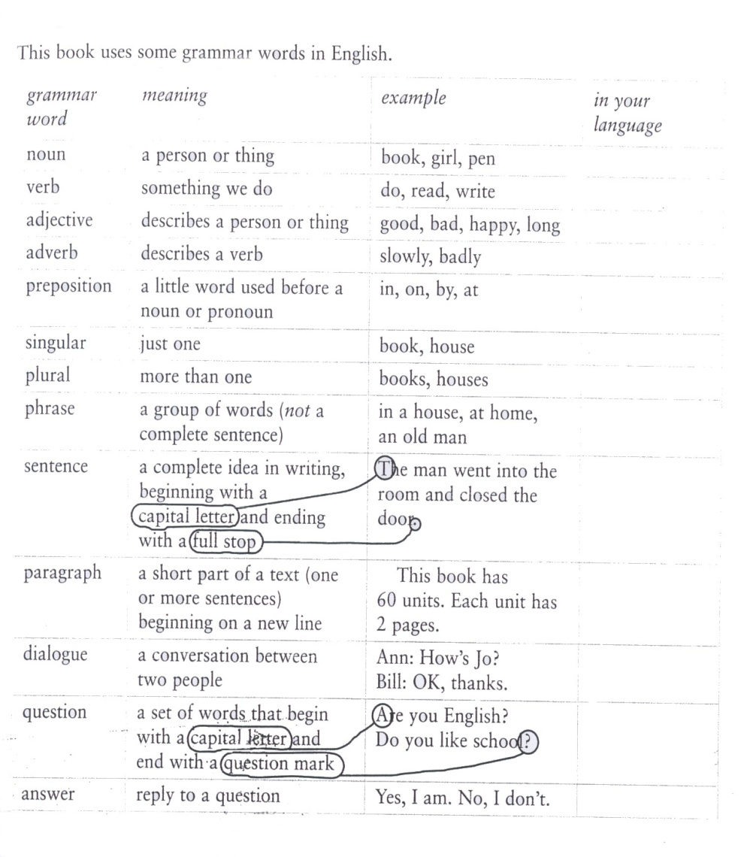

Exercise 46:

Write these words in the correct column.

book speak good word house have
write new man right blue say

Noun | Verb | Adjective
Book

Exercise 47:

Are these phrases, sentences, or questions?

1. in the park phrase
2. Do you speak English?
3. a black cat
4. She is writing a book.
5. What’s your name?
6. I like English.

